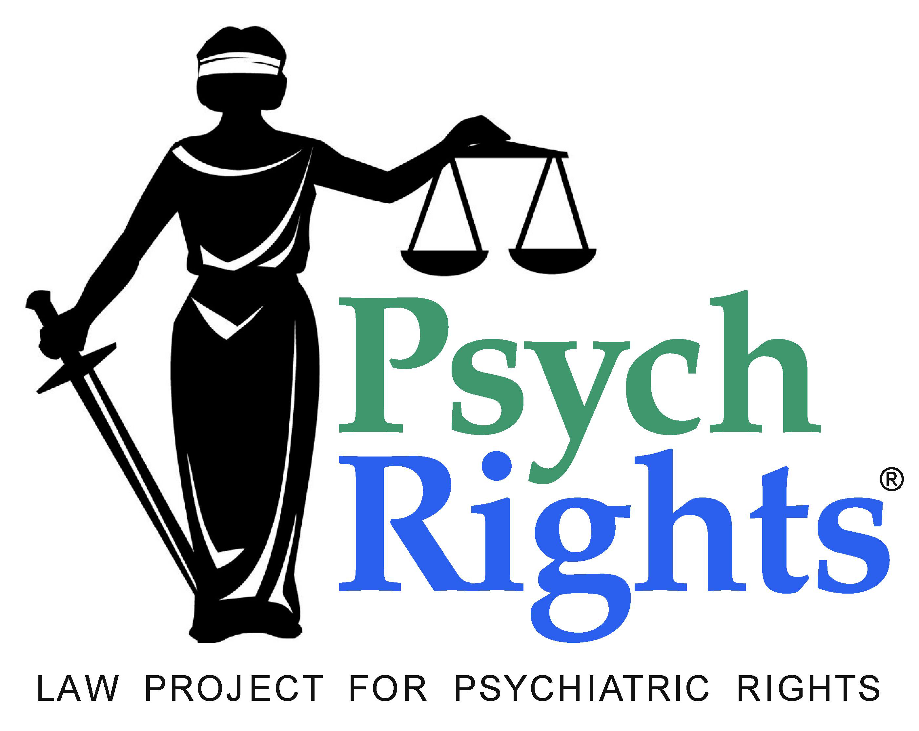




Repeal Mental Health Laws
Documenting and challenging forced psychiatric treatment

Forced Psychiatric Medication Violates Article 7 of the Covenant

Recommendation:

We ask the Committee to make the following concluding observation:

Forced and nonconsensual medication and electroshock, and other coercive and restrictive practices in mental health services, violate article 7 of the Covenant. The United States must take all necessary measures to abolish detention and compulsory treatment in mental health services, and to ensure that mental health services are based only on the free and informed consent of the person concerned.

- The significant suffering and permanent changes to the body and mind caused by psychiatric medications, when imposed without consent or over a person’s objections, amount to torture.

Psychiatric medications (such as neuroleptics) cause significant physical suffering, including uncontrollable, painful movements that can be permanently disfiguring. These medications can interfere with one’s consciousness removing any motivation, self-directed activity, and hope for joy or happiness. They cause permanent changes in the structure of the brain.

Psychiatric medications are commonly delivered either through coercion with threats, or if that is unsuccessful, by holding a person down and violating their bodily integrity, using a needle to perform an injection. Either way, it is traumatic.

These changes to the body and mind, when imposed without consent or over a person’s objections, amount to torture.

- There is no legitimate government interest that can excuse forced psychiatric medication.

The right to free and informed consent to medical treatment is a pillar of personal safety and autonomy, and is one of the factors that distinguish legitimate medical treatments from torture.

Psychiatric drugs are like maiming or corporal punishment. They have no legitimate use to control a person’s behavior, even if that behavior is violent or criminal. Other ways have to be used, the same as with any other person.

A person’s right to make their own decisions, no matter what, is recognized under the Convention on the Rights of Persons with Disabilities, Article 12.

- Forced medication is practiced heavily on vulnerable populations who have even less ability to assert their will.

Forced medication is practiced heavily on children, both those in foster care and those still with their parents. Children have no legal right to refuse.

Forced medication is practiced in jails and prisons, including with the aid of a restraint chair.

Forced medication is practiced on the elderly in nursing homes and psychiatric institutions.

Forced medication is practiced on people of all ages in psychiatric institutions and under outpatient commitment orders (court-ordered treatment outside institutions).

- U.S. law does not prohibit, and at the state level clearly permits, forced psychiatric medication and other restriction of rights and freedoms on the discriminatory basis of perceived disability.

The U.S. Constitution does not clearly prohibit forced medication or other coercive practices in psychiatry.

The standard applied under the Constitution is that there must be a compelling state interest and no less intrusive alternative, and this must be proven by clear and convincing evidence. In practice, state courts routinely grant the requests of psychiatric hospitals to apply forced medication.

All jurisdictions in the U.S. allow forced medication and psychiatric detention.

Forced medication is part of a discriminatory system that places individuals under extreme state control based on psychiatric labeling.

It includes psychiatric detention, the use of restraint and seclusion, and laws that discriminate in child custody, voting rights, access and privacy of health records, the right to travel, and other areas of life.

It includes the reporting of individuals to an FBI criminal database for having been admitted to a psychiatric hospital. This creates a climate that encourages police violence against people who are psychiatrically labeled.

We request the Committee to ask the following questions of the US in its review:

- Does the U.S. Constitution permit or prohibit the nonconsensual administration of psychiatric medications?

- Will the U.S. take steps to enact and enforce laws and policies to prohibit nonconsensual psychiatric medication and other coercive practices in mental health services?

[Note: The U.S. has not made any reservation, declaration or understanding with respect to Article 9. The right to liberty and security of the person can serve as an alternative basis for holding the U.S. accountable to prohibit and prevent nonconsensual psychiatric medication and other coercive practices in mental health services, in addition to Article 7.]

Contact information while in Geneva:
Tina Minkowitz, tminkowitz@earthlink.net, +1-518-321-9839
Aubrey Ellen Shomo, aubrey@aubreyshomo.net
Patricia Bauerle, patricia.bauerle@gmail.com

