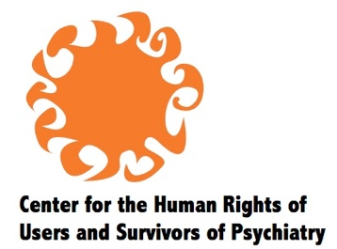

Statement to Caribbean and North American Regional Consultation on Deinstitutionalization

CHRUSP calls for a reparations approach to deinstitutionalization. Institutionalization is a gross human rights violation, which causes harm and creates needs in its victims. It must be decisively abolished through guarantees of non-repetition, and the harms, including impoverishment, psychiatric drug effects and trauma reactions, must be addressed on their own terms. The mental health system cannot be put in charge of supporting individuals socially, economically, or emotionally, to repair harm the system itself has caused. Nor can that system be put in charge of setting new policy or developing legislation to replace the regime of mental health commitment and involuntary treatment.

An alternative approach to policymaking for people experiencing distress or unusual states of consciousness is found within the CRPD itself. Articles 12 and 19 set out positive entitlements to support based on respect for personal autonomy. Consensual support for decision-making and for maintaining one’s daily life at home and in the community offers a new basis for policy that does not rely on the mental health system. Consensual support for emotional healing can be understood as a positive dimension of respect for personal integrity under Article 17, rather than as a health measure.

Legislation is needed to repeal mental health commitment and compulsory treatment laws and to reform legal capacity, criminal procedure, and other areas of law in line with General Comment No. 1 and the Guidelines on Article 14. The provision of support as outlined above does not require a regulatory framework as it has no coercive power and has no relationship to the rights of third parties. However, policy-oriented legislation can be worthwhile to direct organs of the state to initiate programs and make funding available.

Deinstitutionalization must be linked with decarceration related to the criminal justice and immigration systems, as called for by social movements such as Black Lives Matter. People who are subjugated by race and by social class, including many people with disabilities, are over-policed and targeted for police violence. In the US, many police killings have been of people experiencing distress or unusual perceptions, including when police were carrying out involuntary commitment.

The Guidelines on Article 14 set out the obligations to ensure equal access to justice in determinations of criminal responsibility and to promote restorative justice. This should be extended to also promote community-led and PWD-inclusive safety and accountability initiatives as alternatives to policing.

Thank you. Over.

