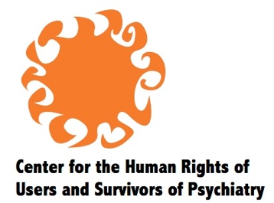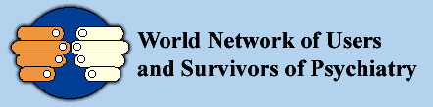

Joint Intervention by the Center for the Human Rights of Users and Survivors of Psychiatry and the World Network of Users and Survivors of Psychiatry

CRPD Conference of States Parties 12th session, Roundtable 2, 12 June 2019

CRPD prohibits forced psychiatric interventions and calls for positive policy instead.

First, mental health crisis must be removed from the category of medical emergencies, and recognized as personal and social in nature.

Second, instead of medical interventions like psychotropic drugs, or repressive ones like detention, we need two kinds of support. We need decision-making support tailored to crisis situations – not support to decide on treatment, but to deal with the situation that has become a crisis in the person’s life.

We also need support to manage practical affairs during a crisis, and to maintain safety and well-being, according to the person’s will and preferences – instead of labeling someone as a ‘danger to self’ and intervening against her will.

Third, to replace the label of ‘danger to others,’ we need police and justice systems that are fair towards people experiencing mental health crisis who are victims of crime or accused offenders, and we need access to conflict resolution for interpersonal disagreements. These functions must be de-linked from support, to differentiate their duty towards multiple parties, from the supporter’s duty of loyalty to a single individual.

This policy complements states’ immediate duty to abolish substitute decision-making and arbitrary detention. Non-coercive mental health services are one way to receive support, but they do not define our crises or play a supervisory role.

I welcome panelists’ views on this approach, which situates mental health crisis fully within the social model of disability of CRPD.

